Applied Cybersecurity: Incident Response, Web Attacks, and Secure System Design

TABLE OF CONTENT

CHAPTER ONE:……………………………………………………………………………………………….…1
SECURITY INCIDENT REPORT: FINANCIAL COMPANY XYZ………………………………………….....1
1.0 Introduction……….………………………………………………………………………………….....1
1.1 Estimated Time for Creaking the Password……………………………………………………………..1
1.2 Information Assessed:……………………………………………………………………………………1
1.3 Criticality Assessment and Recommendation…………………………………………………………...2
1.4 Conclusion……………………………………………………………………………………………….3
1.5 Documented Logbook…………………………………………………………………………………...4
1.6 Screenshots of the Cracked Passwords………………………………………………………………….8
CHAPTER TWO:………………………………………………………………………………………………...11
SECURITY PROTOCOL DESIGN AND ANALYSIS…………………………………………………………..11
2.1 Introduction……………………………………………………………………………………………..11
2.2 Protocol Design…………………………………………………………………………………………11
2.2.1 Protocol Components………………………………………………………………………………...…11
2.2.2 Protocol Workflow……………………………………………………………………………………...13
2.3 Security Goals…………………………………………………………………………………………..16
2.4 Security Analysis……………………………………………………………………………………….16
2.5 Rationale………………………………………………………………………………………………..19
2.6 Conclusion………………………………………………………………………………………….…..20
Contribution Table…………………………………………………………………………………..…..21
CHAPTER THREE:…………………………………………………………………………………………..….22
3.0 Documented logbook of an attack against a webserver………………………………………………...22
3.1 Screenshots of an attack against a webserver…………………………………………………………..27
CHAPTER FOUR:……………………………………………………………………………………………….35
ACCESS CONTROL APPROACHES AND SYSTEMS………………………………………………………..35
4.1 Introduction……………………………………………………………………………………………..35
4.2 Critical Analysis of Access Control Approaches……………………………………………………….36
4.3 Discussion of Related Works…………………………………………………………………………...37
4.4 Future Research Directions……………………………………………………………………………..38
4.5 Conclusion………………………………………………………………………………………………38
REFERENCE…………………………………………………………………………………………...39

CHAPTER ONE
SECURITY INCIDENT REPORT: FINANCIAL COMPANY XYZ

- INTRODUCTION
This report assesses the criticality of the recent security breach at Financial Company XYZ, in which an attacked successfully obtained the employees’ password hash database stored on the main server. The compromised database poses a significant security risk, as password hashes can be cracked, giving the attacker unauthorised access to sensitive system and data.
The primary objective of this assessment is to determine the extent of the potential damage, analyse the risk associated with the exposed password hashes, and make a recommendation on how to mitigate further harm. The findings will help the management prioritise their incident response strategy and reinforce the company’s cybersecurity posture.
1.1 Estimated Time for Creaking the Password:
Single password:
Withing 12 seconds the attacked was able to crack single password by using commonly available lists.
50% of the passwords:
There are six affected accounts, but the attacker successfully cracked passwords for 50% of the targeted accounts within the same 12-seconds timeframe
1.2 Information Assessed:
Padam:
Padam account is an account that contains health information details, the attacker was able to gain access to a file title studentwithdisabilities.txt which includes sensitive health information of two students (Dyslexia, ADHD, learning difficulties).
Pparker:
During the evaluation no sensitive information was found on pparker account.
Chelen:
Chelen account is an employment offers account. The attacker was able to gain access to a file title newstaff.txt, which contained sensitive information about two candidates’ employment offers, including their titles, name and addresses. This data is classified as private, and its unauthorised access is strictly prohibited.

Jdempsey
Jdempsey account is student grades account, the attacker accessed a file named classlist.txt, which contained the names, students IDs, and grades of seven students. This information is sensitive and restricted to authorised personal only.
1.3 Criticality Assessment and Recommendation:
The compromised accounts provided unauthorised access to sensitive data, including personal health information, confidential employment offer details, and student grades. The exposure of this information undermines individuals’ privacy, violates regulatory standards/requirements, and could lead to legal actions against Financial Company XYZ.
Action Required:
Promptly reset all compromised passwords to block the hacker's access and ensure affected account credentials are updated. Implementing regular password changes will reduce the time window in which an attacker can exploit stolen credentials (A. Catalán Goñi, Jahangir and Rajarshi Roy Chowdhury, 2024). Additionally, conducting regular comprehensive security audits will help identify and resolve system vulnerabilities to enhance overall security.
Password Security:
Introduce multi-factor authentication (MFA) to add an extra layer of security, helping to prevent network breaches (Rafah Kareem Mahmood et al., 2024). Enforce strict password policies, including setting complexity requirements and ensuring strong, unique passwords for each account
Regular Staff Training and Access Control Measures:
Implement comprehensive training programs to teach employees how to identify phishing attempts, understand attacker tactics, and respond appropriately to suspicious emails. Encourage the use of password managers to securely store and manage credentials, reducing the risk of unauthorized access due to weak or reused passwords (Sarker et al., 2024). Regularly review user permissions to ensure employees only have access to the information and systems necessary for their roles. Implement a routine process to audit user accounts and promptly deactivate accounts that are no longer active.
Incident Response plan:
Establish a detailed strategy outlining procedures for detecting, responding, and recovering from security incidents, with predefined response actions to ensure a coordinated and efficient reaction. Create effective communication methods to promptly inform impacted individuals and relevant regulatory agencies about security incidents.

Regular Security Audits:
Implementing frequent security audits is essential for detecting potential weaknesses in systems, enabling organizations to proactively identify and address vulnerabilities to reduce the risk of cyberattacks (AL-Hawamleh, 2024). Staying up to date with emerging security threats and promptly applying necessary patches is crucial for maintaining a robust cybersecurity defense.

1.4 Conclusion:
The recent security breach at Financial Company XYZ highlights the urgent need for enhanced cybersecurity measures to protect sensitive data and maintain stakeholder trust. The exposure of private information—including health records, employment details, and student grades—underscores vulnerabilities in the organization’s current systems and practices. By implementing the recommended measures, such as enforcing robust password policies, adopting multi-factor authentication, conducting regular security audits, and training staff on cybersecurity best practices, the company can significantly bolster its defences against future attacks. Additionally, establishing a comprehensive incident response plan ensures a structured and efficient approach to mitigating risks and recovering from potential breaches. These proactive steps are essential for safeguarding sensitive information, ensuring regulatory compliance, and preserving the organization's reputation in an increasingly hostile cyber landscape.

1.5 DOCUMENTED LOGBOOK
Timeline | Task/Command | Observation/Findings
10:22 – 10:22am | Created directory /root/.john, use the unshadow command sudo unshadow passwdcw shadowcw > passwdandshadow.txt to combine two files which are passwdcw and shadowcw  NOTE: The first attempt to run this command failed because the shadow file was not present in the specified directory.  I used sudo john passwdandshadow.txt command to run passwdandshadow.txt fille to crack the password hashes. John the Ripper loaded six hashed passwords, each with unique salt, and was able to crack four of the passwords using predefined wordlist, revealing the plaintext passwords for usernames. The tool used SHA-512 crypt hashing with 5,000 iterations and leveraged multi-threading for faster processing.  NOTE: it switched to incremental brute force mode for the remaining two but were unable to crack within the timeframe, likely due to their complexity. | 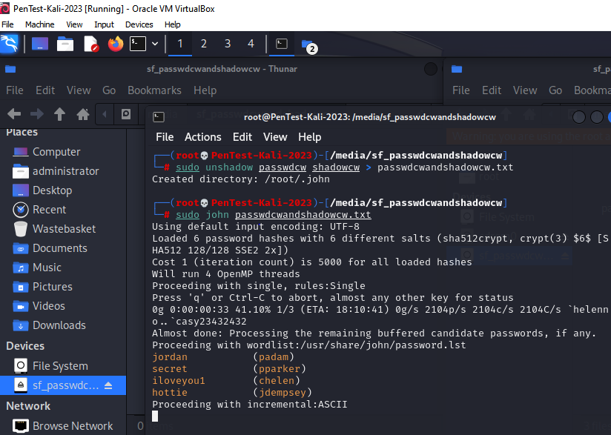  The 4 cracked passwords are :  Username: padam  Password: jordan  Username: pparker  Password: secret  Username: chelen  Password: iloveyou1  Username: jdepsey  Password: hottie  NOTE:The two remaining hashes were for administrator and jbond007.
22:22pm – 22:23am | Logged into the company’s server through CIS4522-CHI after cracking the hashes and obtaining four passwords from the first four usernames.  Logged into the first username account (padam) using the password obtained, after successfully logged in I used ls -a command to list out all the files in the current directory, including the hidden files.  Reading the file:  I ran head on the file studentwithdisabilities.txt to displays the first 10 lines of a file. | 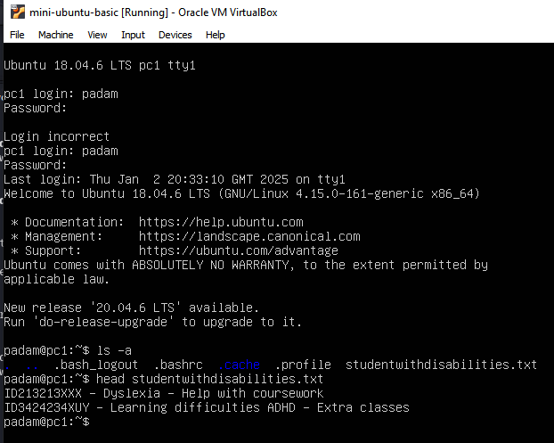  The listed files are :  .bash_logout: a script executed when the user logs out of the terminal.  .bashrc: configuration file for the bash shell, loaded when the shell starts.  .cache: directory for cached data  studentwithdisabilities.txt: file containing information related to student with disabilities.  Content of the file:  Student ID: ID123213XXX and ID3424234XUY  Disability Type: Dyslexia, Learning Difficulties ADHD  Support Provided: Dyslexia: Help with coursework  ADHD: Extra classes  studentwithdisabilities.txt contains personally identifiable information and also personal health information which are sensitive and should be confidential.
22:29pm – 22:33pm | Logged into the second username account (pparker) using the password obtained, after successfully logged in I used ls -a command to list out all the files in the current directory, including the hidden files. | 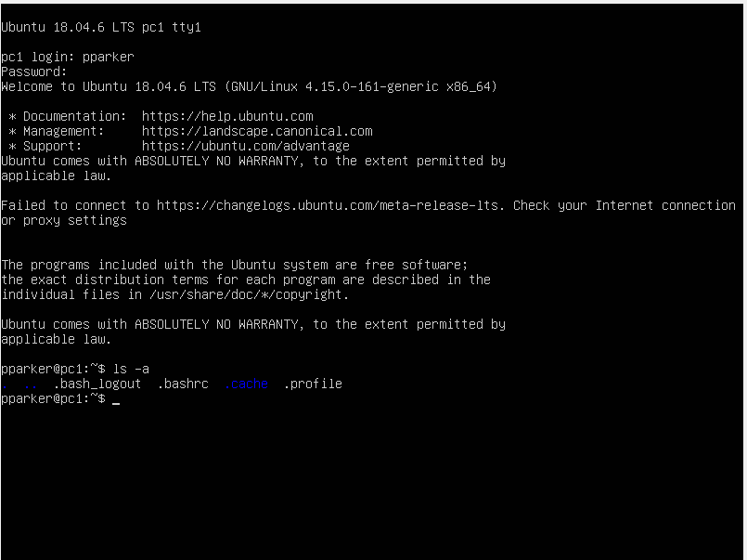  Unable to find sensitive information on pparker account
22:38pm – 22:48pm | Logged into the third username account (chelen) using the password obtained, after successfully logged in I used ls -a command to list out all the files in the current directory, including the hidden files.  Reading the file:  I ran head on the file newstaff.txt to displays the first 10 lines of a file. | I was able to find a visible text file that contains information about new staff (newstaff.txt).  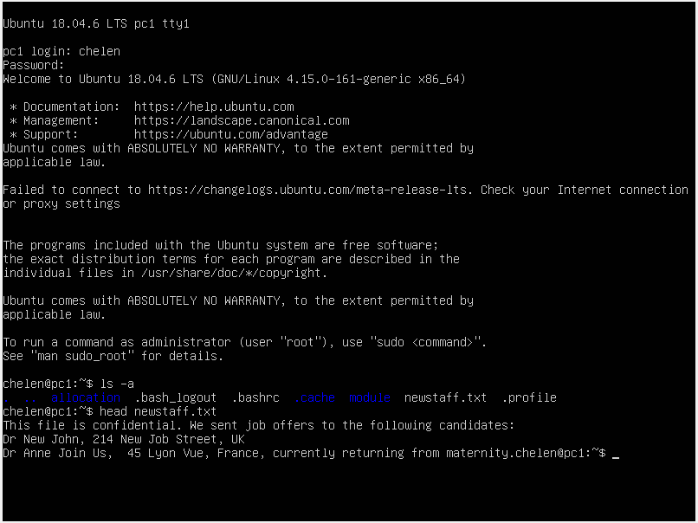  Content of the file:  Dr New John: located at 241 new job street, UK.  Dr Anne Join Us: Located at 45 Lyon Vue, France, and noted to be currently retuning from maternity.  newstaff.txt is a confidential file that contains sensitive information about job offers, including candidates’ tittle, names, addresses, professional details such as maternity leave. The file is marked confidential, meaning unauthorised person should not be allowed to access it.
22:53pm – 23-03pm | Logged into the fourth username account (jdempsey) using the password obtained, after successfully logged in I used ls -a command to list out all the files in the current directory, including the hidden files.  Reading the file:  I ran head on the file classlist.txt to displays the first 10 lines of a file. | I was able to find a visible text file (classlist.txt) that contains seven students’ name, ID and Grades.  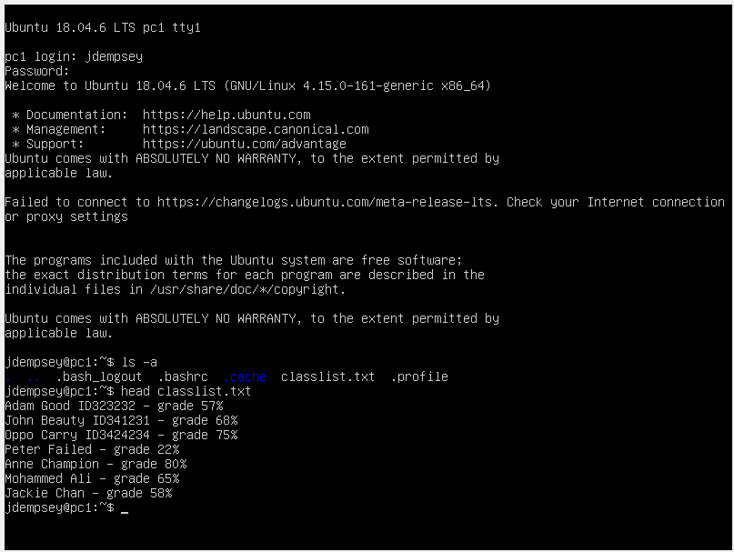  Content of the file:  Adam Good ID233232 - grade 57%  John Beauty ID344231 - grade 68%  Oppo Carry ID342234 - grade 75%  Peter Failed - grade 22%  Anne Champion - grade 80%  Mohammed Ali - grade 65%  Jackie Chan - grade 58%  This information is highly confidential and should only be accessed by authorised individual and the institution.

1.6 SCREENSHOTS OF THE CRACKED PASSWORDS
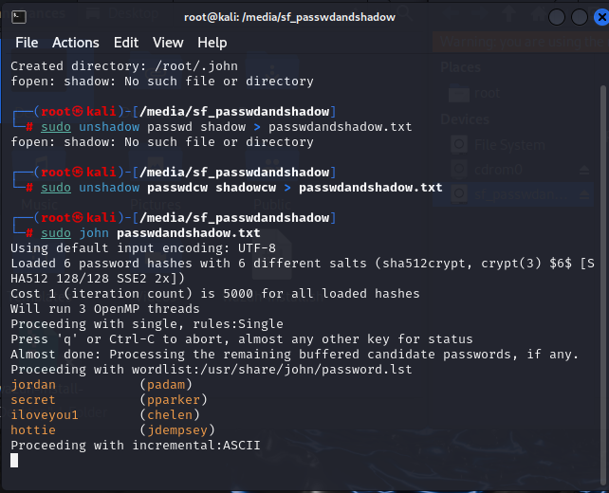

- padam profile
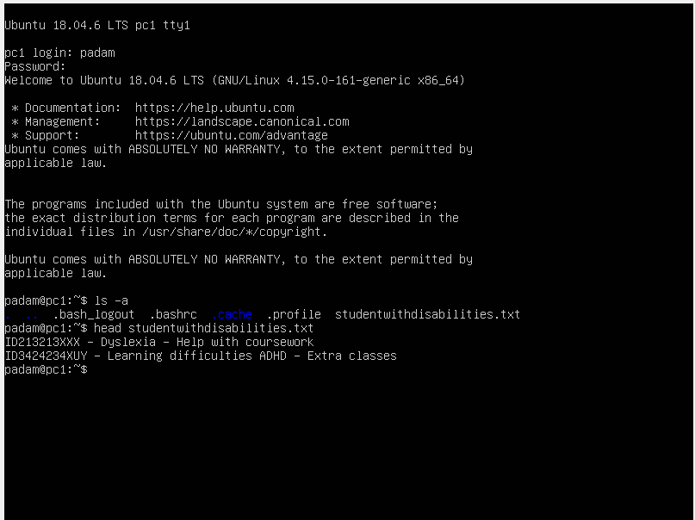

- pparker profile

- chelen profile
- jdempsey profile

CHAPTER TWO
SECURITY PROTOCOL DESIGN AND ANALYSIS
2.1 Introduction
With the rapid growth of the Internet of Things (IoT), devices such as smart fridges are becoming integral to everyday life, offering automation and convenience (Kumar and Bargavi, 2023). However, the increasing interconnectivity of these devices introduces significant security challenges, especially when they handle sensitive data, such as personal preferences, inventory updates, and payment information (Taherdoost, 2023). In this context, securing communication between a smart fridge and a supermarket’s backend system is crucial to ensure that sensitive user data remains protected from various security threats.
This report presents a theoretical security protocol designed to ensure secure communication between a smart fridge and a supermarket. The protocol addresses the fundamental security concerns of confidentiality, integrity, and authentication, ensuring that the data exchanged remains private, accurate, and trustworthy. The report outlines the design of the protocol, the security mechanisms employed, and a detailed security analysis, followed by a rationale justifying the design choices. Additionally, the limitations of the protocol are discussed, and potential improvements are proposed to enhance its security and performance in an evolving IoT environment.
2.2 Protocol Design
Smart Fridge-Supermarket Secure Communication Protocol (SFSSCP)
To secure communication between the smart fridge and the supermarket backend, our team developed a comprehensive security protocol that ensures confidentiality, integrity, and authentication. This protocol addresses critical threats, including eavesdropping, message alteration, spoofing, replay attacks, and man-in-the-middle attacks, by integrating encryption, digital signatures, nonce-based replay protection, and robust authentication mechanisms.
2.2.1 Protocol Components
Encryption
The protocol utilizes asymmetric encryption (also known as public-key cryptography) to safeguard the confidentiality of sensitive data exchanged between the fridge and the supermarket. When the fridge sends a message, it encrypts the data using the supermarket’s public key (Naveen and Prakash, 2021). This ensures that only the supermarket, with its corresponding private key, can decrypt and access the message content. Likewise, when the supermarket responds, it encrypts its messages using the fridge’s public key. Only the fridge can decrypt the supermarket's responses using its private key. This two-way encryption ensures that the data remains confidential and cannot be intercepted or read by unauthorized third parties (Ravi, 2024).
Digital Signatures
To provide message authentication and integrity, the sender signs each message with its private key (Gerodimos et al., 2023). The recipient uses the sender’s public key to verify the digital signature. This not only authenticates the origin of the message, ensuring it is from the legitimate party (the fridge or the supermarket) but also guarantees the integrity of the message. If the message is altered during transmission, the signature validation will fail, alerting the recipient to potential tampering (Boolakee et al., 2021). This ensures that both authenticity and data integrity are maintained throughout the communication process.
Nonce and Timestamp
Each message includes a unique nonce (a random number used once) or timestamp that marks the freshness of the message. The use of nonces or timestamps ensures that each communication instance is distinct and prevents malicious actors from capturing and retransmitting earlier messages (Gerodimos et al., 2023). This mechanism guarantees that a message is not reused maliciously, protecting the communication from duplication or fraudulent actions.
Mutual Authentication
Mutual authentication is a key security feature that ensures both the fridge, and the supermarket authenticate each other before any sensitive data exchange occurs. This is achieved through the use of digital certificates issued by a trusted Certificate Authority (CA) (Ravi, 2024). The certificates validate the authenticity of the public keys used by both parties, ensuring that neither the fridge nor the supermarket is impersonated by an unauthorized entity (Ravi, 2024). Mutual authentication protects communication against spoofing attacks, where an attacker could pose as one of the legitimate parties to gain unauthorised access or send fraudulent data (Goyal et al., 2020).

Secure Communication Channel (TLS)
To further protect the data in transit, the protocol uses TLS (Transport Layer Security) to establish a secure communication channel between the fridge and the supermarket backend. TLS provides end-to-end encryption for all data exchanged over the channel, ensuring confidentiality and integrity during transmission (Naveen and Prakash, 2021). It also protects against man-in-the-middle attacks, as TLS uses both encryption and certificate-based authentication to verify the identity of the communicating parties.
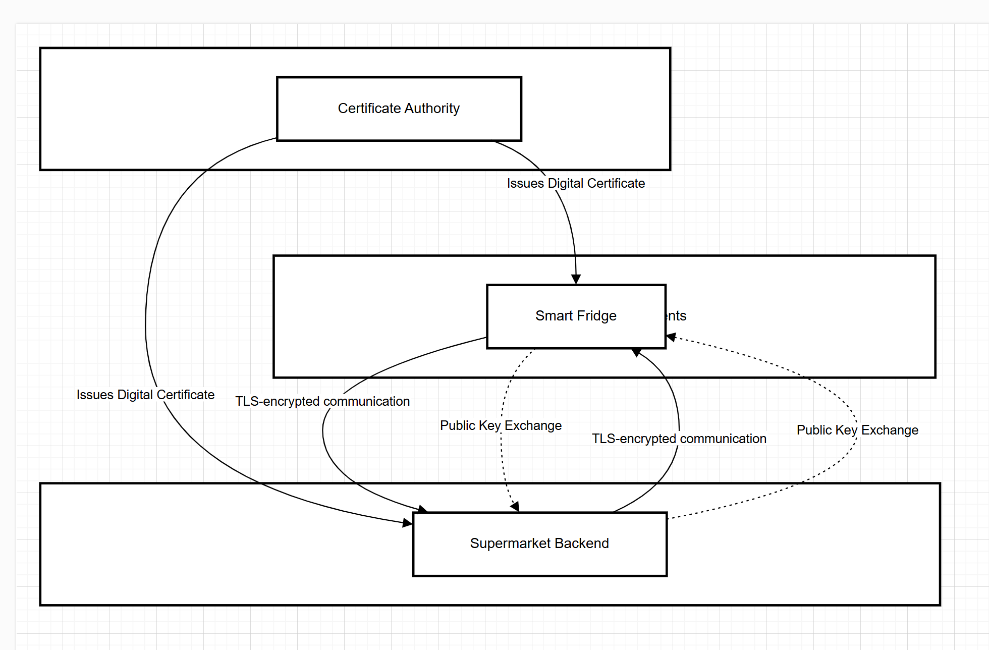
Figure 1: System Architecture for Secure Communication Between Smart Fridge and Supermarket

2.2.2 Protocol Workflow
Initialisation (One-Time Setup):
During the initial setup, the smart fridge and the supermarket backend are each provisioned with unique public-private key pairs, ensuring that both parties have secure cryptographic identities (Narayana and Gopi, 2021). To establish a trust foundation, the fridge and the supermarket exchange digital certificates issued by a trusted Certificate Authority (CA). These certificates validate the authenticity of their respective public keys and enable mutual authentication, creating a secure chain of trust for subsequent communications (Ravi, 2024).
Communication Steps:
Fridge to Supermarket
The fridge initiates secure communication by generating a message containing either an inventory update or an order request, depending on its operational needs (Boolakee et al., 2021). To protect against replay attacks, a unique nonce or timestamp is included, ensuring that an attacker cannot reuse the message. The message is then encrypted using the supermarket’s public key, guaranteeing that only the supermarket can decrypt the content. Subsequently, the fridge digitally signs the encrypted message with its private key. This signature ensures the integrity of the message, preventing tampering during transmission, and provides authentication by allowing the supermarket to verify the origin of the message using the fridge’s public key (Narayana and Gopi, 2021). Once these steps are completed, the message is transmitted over the communication channel to the supermarket backend.
Supermarket to Fridge
In response, the supermarket generates a message containing order confirmations, delivery statuses, or grocery recommendations based on the inventory data provided by the fridge. A unique nonce or timestamp is appended to the response to ensure the freshness of the message and to prevent replay attacks (Gerodimos et al., 2023). The message is then encrypted with the fridge’s public key, ensuring confidentiality. Following encryption, the supermarket signs the message using its private key, which assures the message’s authenticity and integrity. The fridge verifies the signature upon receipt, ensuring the message originates from a legitimate supermarket and has not been altered in transit. This signed and encrypted response is then transmitted back to the fridge, completing the secure exchange (Naveen and Prakash, 2021).
Error Handling:
The protocol incorporates robust error-handling mechanisms to detect and respond to security violations (Goyal et al., 2020). Messages with invalid signatures, mismatched timestamps, or reused nonces are immediately rejected, and the corresponding events are logged. In case of repeated suspicious activities, such as authentication failures or replay attempts, alerts are triggered, notifying the user to take corrective actions (Hosenkhan and Pattanayak, 2021). These mechanisms ensure resilience against attacks, while also maintaining the system's operational integrity.

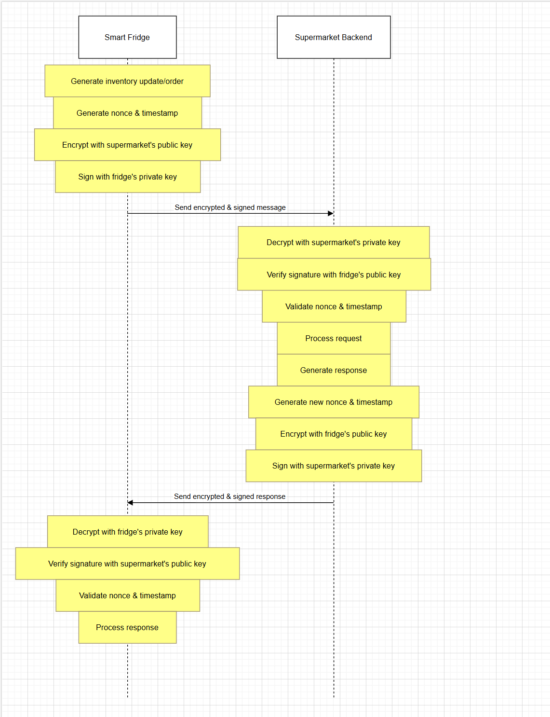
Figure 2: Secure Communication Protocol Between Smart Fridge and Supermarket

2.3 Security Goals
The protocol must achieve three primary security goals to ensure a secure communication channel between the smart fridge and the supermarket: Confidentiality, Integrity, and Authentication. These goals guide the development of the protocol and address vulnerabilities identified in the security analysis.
Confidentiality ensures that sensitive data, such as inventory updates, order requests, and personal details, remains inaccessible to unauthorized entities (Prakash et al., 2024). This is crucial as the communication involves private information about shopping habits, preferences, and potential financial transactions. Encryption guarantees that only the intended recipients can read the transmitted messages (Ntayagabiri et al., 2024). Integrity ensures that data exchanged between the fridge and the supermarket is not altered during transmission. Modifications in transit—whether intentional or due to system failure could lead to incorrect orders or malicious deliveries.
Digital signatures and message integrity checks safeguard against such attacks, ensuring the data remains trustworthy (Khan et al., 2022). Authentication ensures that both the fridge and the supermarket are verified, preventing impersonation attacks where an attacker could send fraudulent messages. Without proper authentication, fake devices could lead to fraudulent orders or misleading recommendations.
These three goals are foundational to the communication protocol, safeguarding user privacy, maintaining accuracy, and preventing malicious activities such as fraud or unauthorized access.
2.4 Security Analysis
Eavesdropping (Confidentiality Attack)
Eavesdropping attacks involve intercepting communication between the fridge and the supermarket, aiming to steal sensitive data like inventory, personal details, and payment information (Taherdoost, 2023). To prevent eavesdropping, the protocol employs TLS (Transport Layer Security) to encrypt all communication between the fridge and the supermarket, ensuring confidentiality. TLS 1.2 or 1.3 is utilized due to their support for strong encryption algorithms and forward secrecy, which ensures that session keys are not compromised even if a long-term key is exposed (Raghuprasad et al., 2020).
In addition, asymmetric encryption is employed, where the fridge encrypts its messages using the supermarket’s public key, and the supermarket encrypts its responses using the fridge’s public key. Only the intended recipient, who possesses the corresponding private key, can decrypt the messages (Sarkar, 2023). According to Prakash et al. (2024), this guarantees that even if an attacker intercepts the communication, they cannot decrypt the messages without the private key.
Message Alteration (Integrity Attack)
In this scenario, an attacker may attempt to modify messages exchanged between the fridge and the supermarket, such as altering inventory updates or order requests. To safeguard against this, the protocol employs digital signatures. Each message is signed using the sender’s private key, ensuring that the recipient can verify the authenticity and integrity of the message (Prakash et al., 2024). The recipient uses the sender’s public key to validate the signature, ensuring the message has not been tampered with during transmission.
Furthermore, TLS ensures that data integrity is maintained through mechanisms like Message Authentication Codes (MACs), which protect against any modifications in the communication stream during transit (Hosenkhan and Pattanayak, 2021).
Spoofing (Authentication Attack)
Spoofing attacks involve impersonating either the fridge or the supermarket to send fraudulent messages (Chatterjee & Ray, 2022). To prevent such attacks, the protocol utilizes mutual authentication through digital certificates issued by a trusted Certificate Authority (CA) (Gerodimos et al., 2022). This ensures both the fridge, and the supermarket authenticate each other before any sensitive data is exchanged.
The fridge and supermarket exchange certificates, verifying their identities and ensuring that each party is who they claim to be. This prevents unauthorized entities from impersonating either side and gaining access to sensitive information or performing malicious actions like sending deceptive recommendations or orders (Chatterjee & Ray, 2022).
Replay Attacks
Replay attacks occur when an attacker intercepts and replays valid messages to confuse the system, such as repeating order requests or inventory updates (Sarkar, 2023). To counter this, the protocol incorporates nonces and timestamps in each message. The nonce is a random value that ensures each message is unique, preventing attackers from reusing intercepted messages (Boolakee et al., 2021). Additionally, the timestamp verifies that the message is fresh and has not been delayed or replayed. If the timestamp exceeds a specified threshold, the message is considered invalid and discarded, mitigating the risk of replay attacks (Boolakee et al., 2021).
Man-in-the-Middle (MitM) Attack
A Man-in-the-Middle (MitM) attack occurs when an attacker positions themselves between the fridge and the supermarket, intercepting and potentially altering communication in real time (Sarkar, 2023). To defend against this, the protocol relies on TLS encryption, which secures the entire communication channel between the fridge and the supermarket. This ensures that all messages are encrypted, and any tampering or interception of the messages will result in failure to decrypt them correctly (Naveen and Prakash, 2021).
Additionally, mutual authentication via digital certificates prevents attackers from impersonating either the fridge or the supermarket, as both parties must prove their identity before communication can begin (Sarkar, 2023). This layered defence helps mitigate the risk of MitM attacks.
Denial of Service (DoS)
A Denial of Service (DoS) attack could disrupt the communication between the fridge and the supermarket by overwhelming the system with malicious traffic or exploiting vulnerabilities in the network or application (Ntayagabiri et al., 2024). To mitigate DoS attacks, the protocol incorporates several network-level defence mechanisms, including rate limiting to control the number of requests that can be made in a given time. IP whitelisting can be used to ensure that only trusted devices (e.g., the fridge and supermarket backend) can initiate communication, further protecting against potential DoS attacks (Raghuprasad et al., 2020).
Additionally, firewalls and intrusion detection systems (IDS) can be employed at both the fridge and supermarket ends to monitor and block malicious traffic or abnormal patterns indicative of DoS attacks.
Data Breaches
Data breaches involve attackers gaining unauthorised access to the supermarket's backend systems to steal personal user data, including order histories, preferences, and financial details (Khan et al., 2022). To protect against this, the protocol employs end-to-end encryption using TLS for secure transmission of sensitive information, ensuring that even if an attacker intercepts the communication, the data remains unreadable (Hosenkhan and Pattanayak, 2021).
On the supermarket’s backend, data-at-rest encryption ensures that any stored user data is also protected. Access control mechanisms can be implemented to ensure that only authorised personnel and systems have access to sensitive data (Khan et al., 2022). Additionally, regular security audits and vulnerability assessments can help identify and address potential weaknesses in the system.

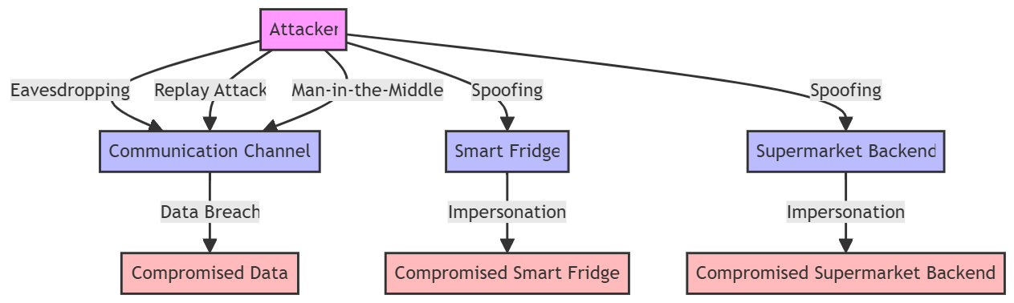

Figure 3: Threat Model Flowchart for Smart Fridge and Supermarket Communication

2.5 Rationale
The design of the secure communication protocol between the smart fridge and the supermarket prioritizes confidentiality, integrity, and authentication to safeguard sensitive data during transmission. Each security mechanism was selected to address specific risks and ensure secure exchanges of inventory updates, order requests, and payment information.
Asymmetric encryption ensures confidentiality, preventing unauthorized access to sensitive data. Digital signatures were implemented to guarantee message authenticity and prevent tampering, reinforcing trust in the data exchanged. Mutual authentication, using digital certificates, was selected to verify the identity of both the fridge and the supermarket, thus protecting against impersonation. Nonces and timestamps ensure the freshness of messages, safeguarding against replay attacks. Finally, additional safeguards such as rate limiting and intrusion detection systems were included to mitigate Denial of Service (DoS) attacks, ensuring continuous secure operation.
These decisions ensure that the protocol remains resilient to key threats while maintaining high-security standards, protecting both the sensitive data in transit and the integrity of communication between the fridge and the supermarket.

2.6 Conclusion
The secure communication protocol designed for the smart fridge and supermarket effectively addresses the core security goals of confidentiality, integrity, and authentication. By incorporating asymmetric encryption, digital signatures, and mutual authentication, the protocol ensures that sensitive data—such as inventory updates and order requests—remains secure from unauthorized access and tampering. Transport Layer Security (TLS) further strengthens the communication channel, providing reliable protection against eavesdropping, while anti-replay measures like nonces and timestamps reinforce the system’s security.
The protocol is well-equipped to defend against key threats such as Man-in-the-Middle (MitM) and spoofing, ensuring secure, trusted communication between the fridge and supermarket. These robust security mechanisms provide a strong foundation for real-world implementation within the connected IoT ecosystem.
Overall, the protocol offers a reliable and secure solution for communication, with the potential for seamless integration into diverse IoT environments. However, ongoing research and refinement will be critical to addressing emerging security challenges and optimizing performance in an evolving IoT landscape.

Contribution Table
Table 1: Contribution Table
Team Member | Contribution
Okedere Obanijesu  26049384 | - Designed the protocol's encryption and digital signature mechanisms.  - Conducted the security analysis, addressing confidentiality and integrity attacks.  - Drafted the rationale section justifying the design choices.  - Assisted in writing the conclusion and proposed improvements.
Janefrances Ifeyinwa Uba  25985388 | - Developed the mutual authentication and anti-replay mechanisms.  - Analysed the security of the protocol, focusing on authentication and replay attacks.  - Contributed to the rationale section by explaining the choice of mutual authentication.  - Edited and finalised the report for consistency and clarity.
Otori Samson  26025744 | - Designed the protocol workflow and communication steps.  - Drafted the introduction and conclusion sections.  - Focused on the analysis of Man-in-the-Middle (MitM) and DoS attacks.  - Assisted in the creation of the report structure and formatting.

CHAPTER THREE
3.0 DOCUMENTED LOGBOOK OF AN ATTACK AGAINST A WEBSERVER
Timeline | Tool/Command | Findings
02/01/2025  16:02 | Ifconfig command to get IP address of the victim machine | The command output show that the system has two network interface eth0 and lo.  eth0: it’s an ethernet interface with an IP address of 192.168.56.102. and lo: it’s a loopback interface with an IP address of 127.0.0.1.  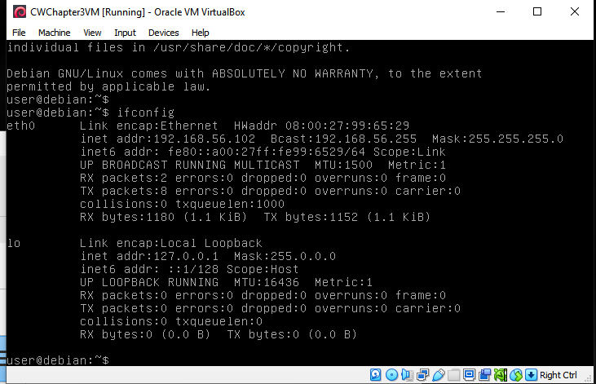
02/01/2025  16:06 | NMAP command for vulnerability scan: nmap -O -p- -sCV -vv 192.168.56.102 | Vulnerability assessment was performed on webserver with IP address 192.168.56.102. the scan Identified two open ports on the target system, port 22 running SSH and port 80 running HTTP, also detected specific software versions associated with these services, such as OpenSSH 5.5 on port 22 and Apache 2.2.16 on port 80. The operating system of the target was determined to be Debian, providing insight into the underlying environment and its configuration.  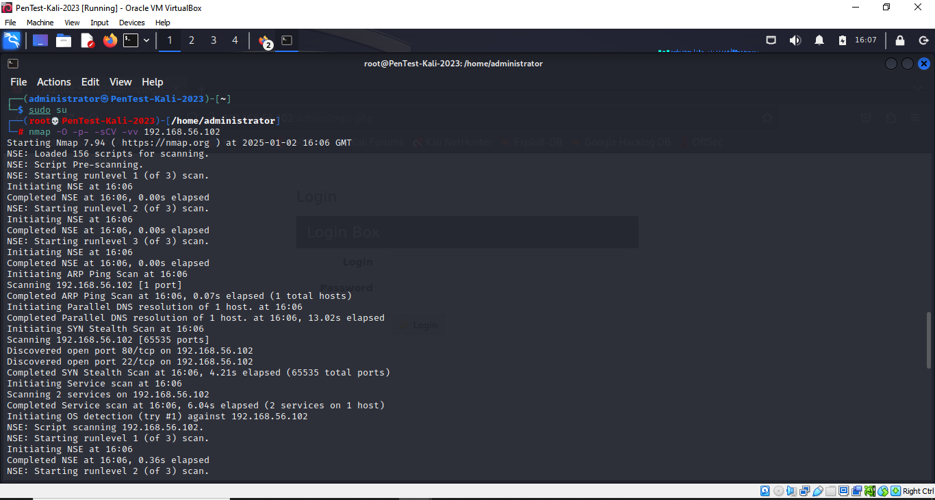
02/01/2025  16:17pm | URL http://192.168.56.102/cat.php?id=1” | My Awesome Photoblog displayed an SQL syntax error. This indicates a potential vulnerability to SQL injection attacks.  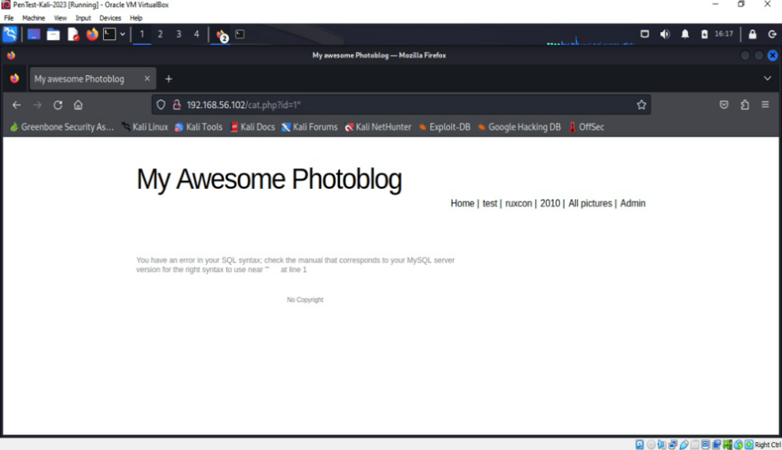
02/01/2025  16:32:05 | Sqlmap: sqlmap -u http://192.168.56.102/cat.php?id=1 -dbs | Extracted two databases : information_schema a system database and Photoblog user-created and the back-end database is MySQL 5.0.12, hosted on a Linux Debian 6 server with Apache 2.2.16 and PHP 5.3.3.  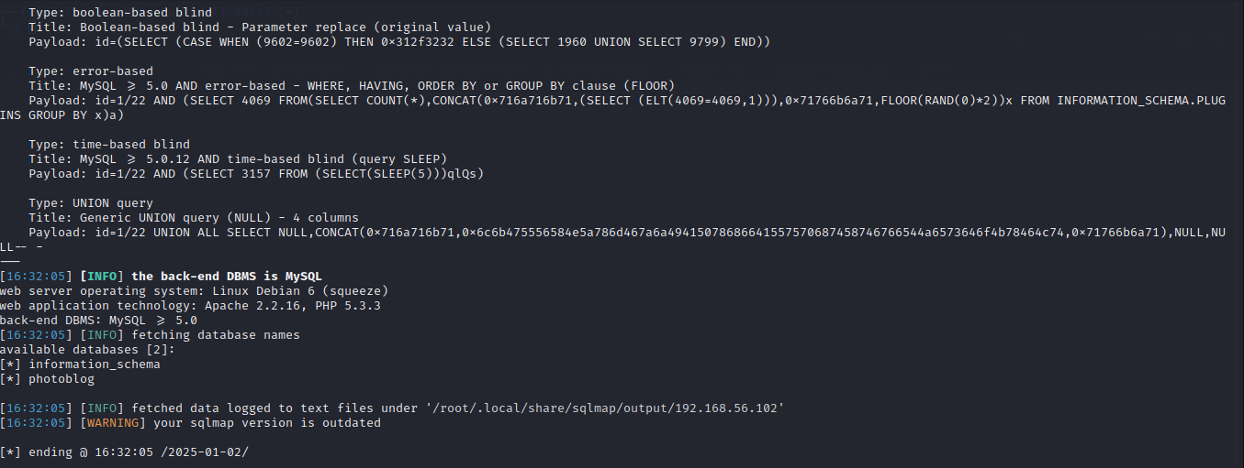
02/01/2025  16:48:53 | sqlmap -u "http://192.168.56.102/cat.php?id=1 -D photoblog –tables | We tested id=1 parameter is vulnerable to SQL injection by instructing SQLMap to identify and enumerate all databases available on the back-end system. Assessed web application hosted at 192.168.56.102 and it identifies that photoblog contains three tables: categories, pictures, and users.  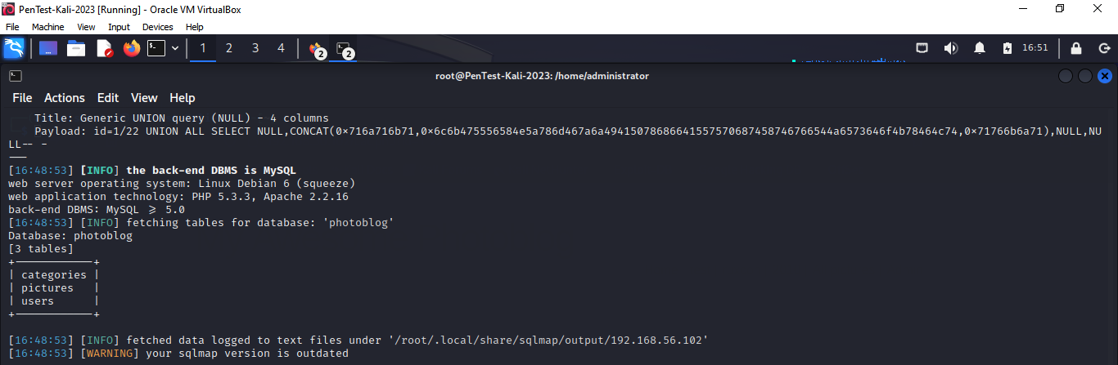
02/01/2025  16:49:37 | sqlmap -u http://192.168.56.102/cat.php?id=1 -T users --columns | We used SQLMap to list the column details from the users table in the photoblog database of the vulnerable IP 192.168.56.102, we were able to retrieve columns name “users” table: ID, login , password.  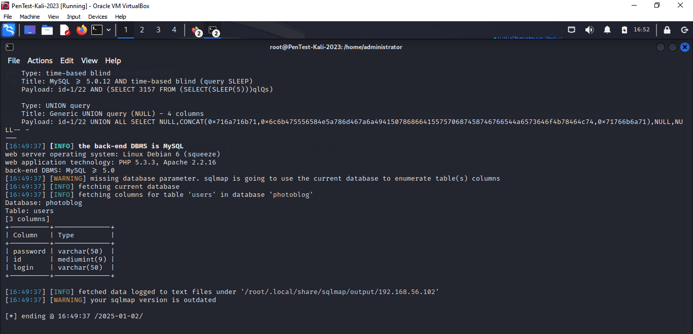
02/01/2025  17:04:59 | sqlmap -u "http://192.168.56.102/cat.php?id=1 -D photoblog -T users -dump | Extracted and cracked admin password from the user table in the photoblog database using SQLMap. SQLMap employs a dictionary-based attack to crack the hashed password, revealing the plaintext password as P4ssw0rd  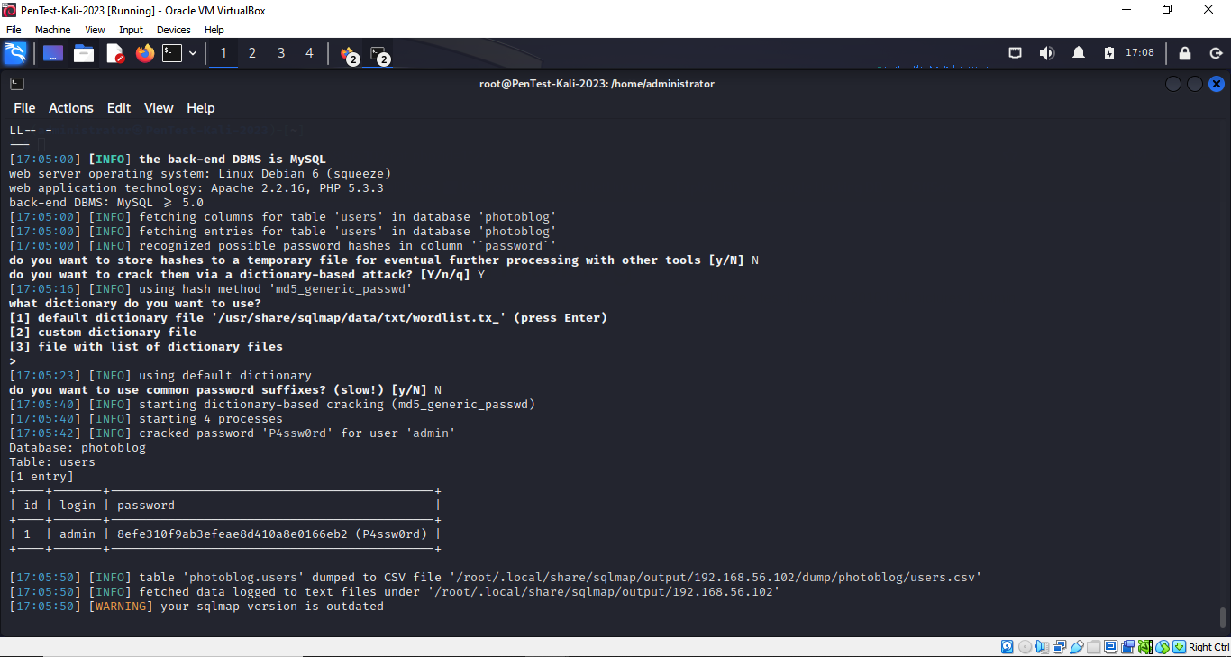
02/01/2025  17:09:00 | Critical discussion of the vulnerabilities and recommendation | The SQL injection vulnerability identified poses a significant security threat, enabling attackers to alter database queries and gain unauthorised access or manipulate data. This issue arises from the absence of adequate input validation and sanitisation mechanisms. The vulnerability specifically affects the ⁠ cat.php ⁠ page, leaving the web application exposed to such attacks.  The ability to enumerate databases, tables, and user accounts highlights insufficient security measures. The discovered admin password from the admin account poses a critical vulnerability, particularly due to its capability to delete files. Such unauthorised access could result in data loss and further exploitation.  Recommendations:  To mitigate SQL injection vulnerabilities, robust input validation should be implemented along with parameterized queries. Strong password policies must be enforced, and passwords should be secured using encryption or hashing techniques with salting. Access controls should be reinforced to prevent unauthorised actions, such as file deletion, even by authenticated users. Furthermore, the operating system, web server, and database management system must be regularly updated with the latest security patches to address existing vulnerabilities.
02/01/2025  17:12:00  11/01/2025  11:35:49 | Webserver admin account login  Dirb scan: dirb http://192.168.56.102 | We successfully login with the username: admin and password: P4ssw0rd obtained, noticed that the panel allows deleting of image file named: Hacker, Ruby, Cthulhu and adding a new picture on the web application.  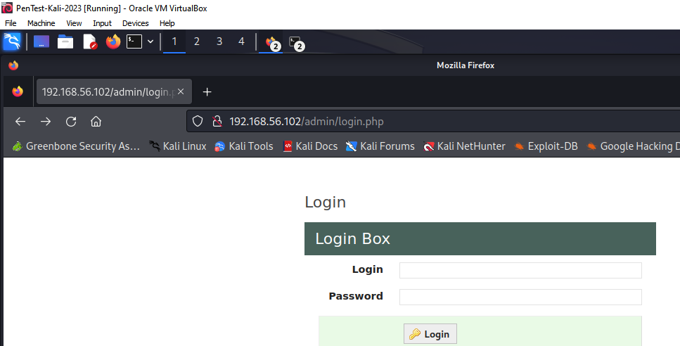  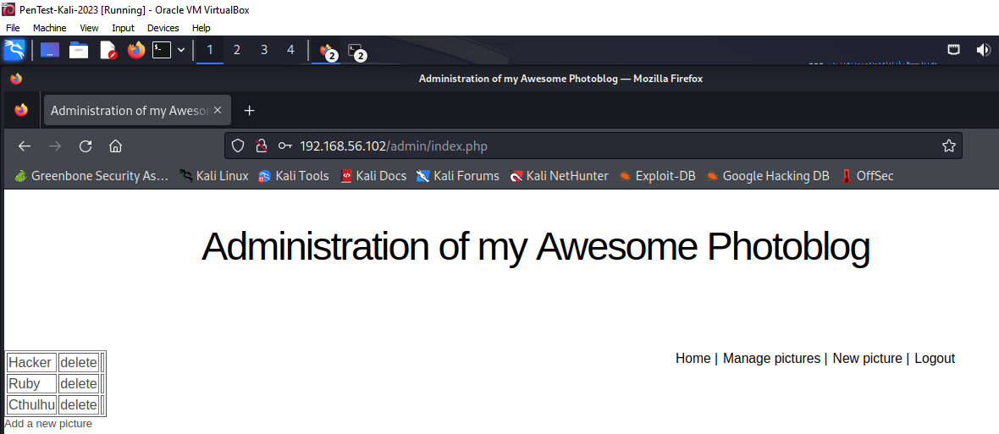  Findings  DIRB identified several directories, including /admin/, /classes/, /css/, /images/, and /uploads/, with some flagged as listable, allowing public browsing of their contents and posing a security risk. The listable directories, such as /classes/ and /uploads/, expose sensitive files to potential attackers, emphasizing the need for stricter access controls and server configuration. The /admin/ directory and its subpaths, such as /del, /header, and /logout, could expose sensitive operations, providing attackers with potential administrative access.  Recommendation:  Implement strict access controls for the /admin/ directory, such as IP whitelisting or multi-factor authentication, restrict access to unnecessary directories and regularly perform vulnerability assessments to identify and address emerging threats.  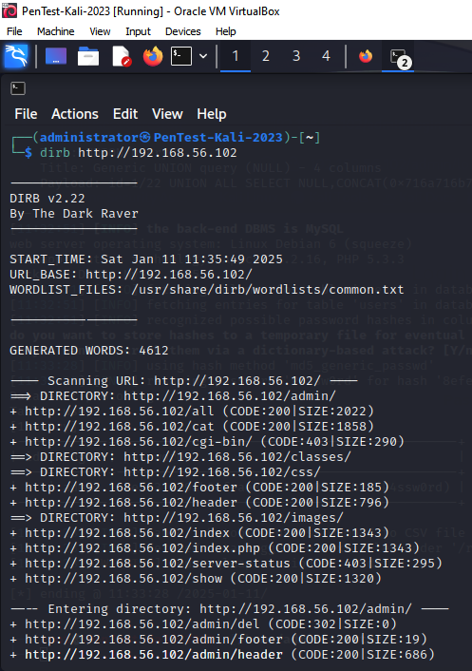  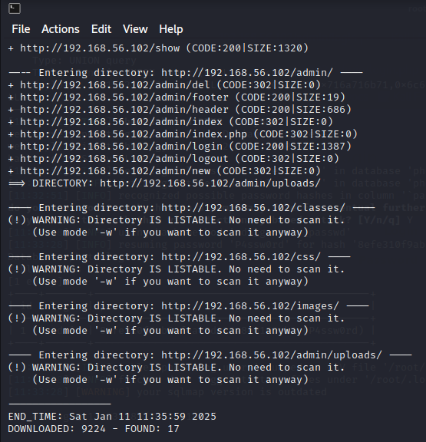

3.1 SCREENSHOTS

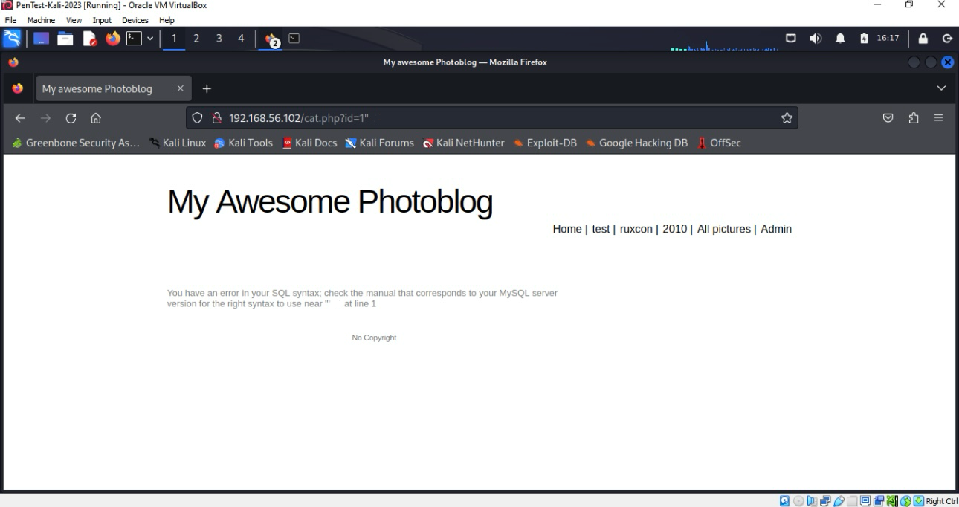

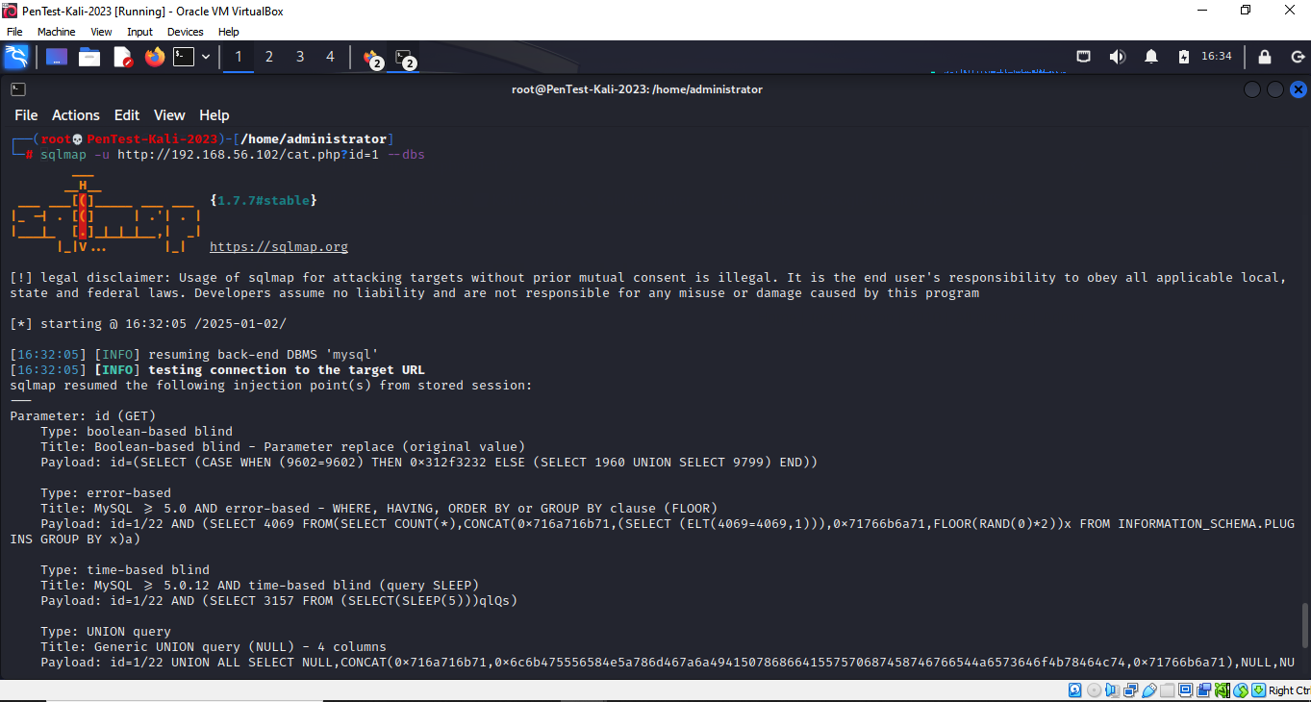

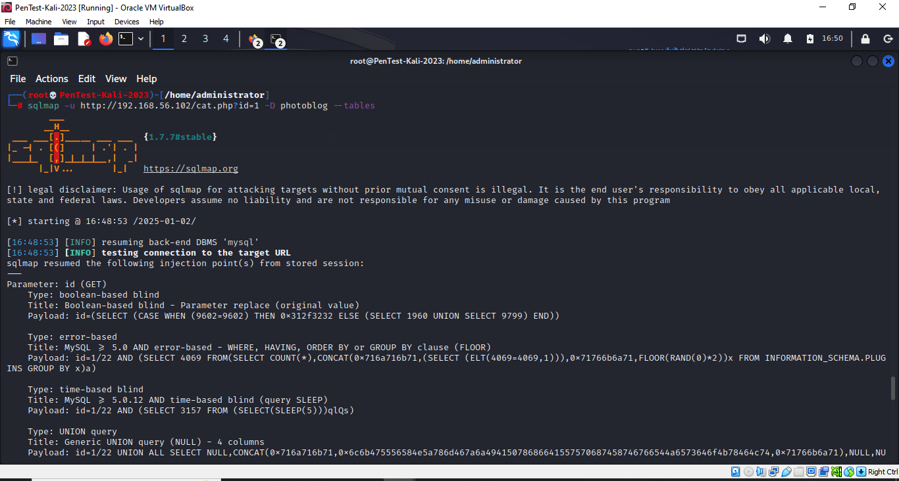

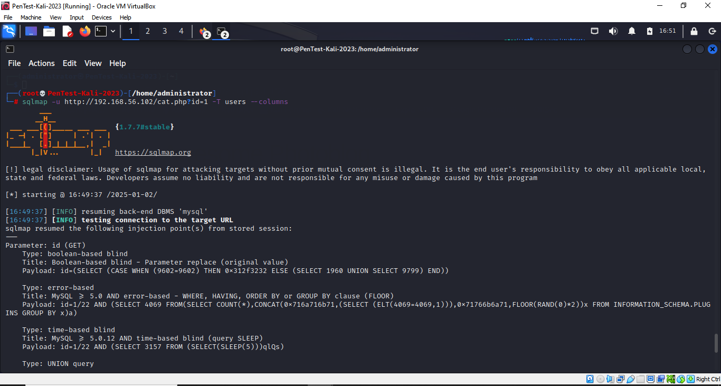

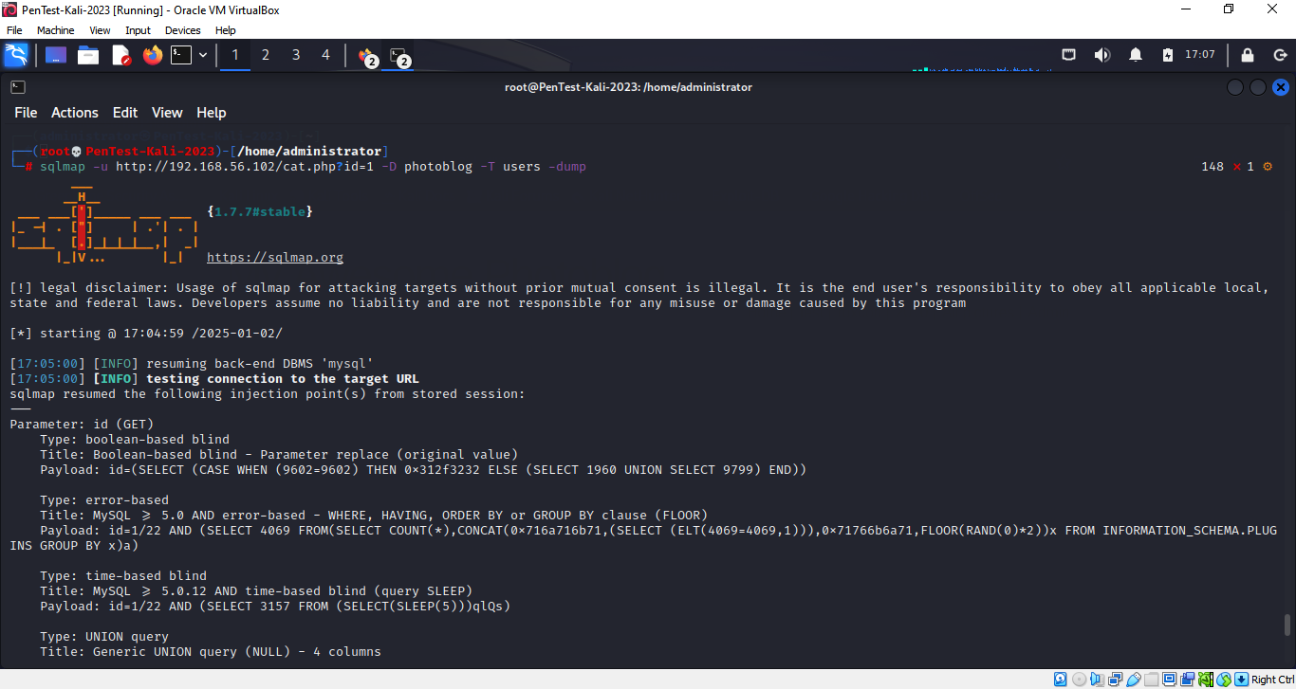

CHAPTER FOUR
ACCESS CONTROL APPROACHES AND SYSTEMS

4.1 Introduction
Access control models are integral to the security infrastructure of organizations, playing a pivotal role in protecting systems from unauthorized access and mitigating insider threats (Choudhary & Singh, 2022). As digital transformation accelerates, organizations are increasingly exposed to complex security risks, particularly from within their networks (Penelova, 2021). Insider threats, whether malicious or accidental, can be just as damaging as external attacks, making it imperative for organizations to adopt robust and adaptive access control mechanisms (Olaoye & Egon, 2024). While no single access control model offers a perfect solution for every scenario, different models have been developed to address various aspects of access management, each with its strengths and limitations. Among the most widely discussed and implemented models are Role-Based Access Control (RBAC) and Zero Trust architectures (Choudhary & Singh, 2022).
RBAC, which assigns permissions based on predefined roles within an organization, is known for its simplicity and efficiency in managing user access in stable and well-defined environments (Butt et al., 2023). However, in dynamic or rapidly evolving systems, RBAC can struggle with flexibility, particularly when managing access in real-time or across complex, heterogeneous environments (Penelova, 2021). Zero Trust, on the other hand, operates on the principle of "never trust, always verify," continuously evaluating every access request, regardless of the user's location or network (Teerakanok et al., 2021). This model promises to enhance security by minimizing the risk of insider threats but requires significant investment in technology and resources, making its implementation complex.
This study explores the effectiveness of RBAC and Zero Trust models in mitigating insider threats. Specifically, the research question guiding this investigation is: How effective are Role-Based Access Control (RBAC) and Zero Trust models in mitigating insider threats? This study will explore the strengths and weaknesses of these models, examining how they address insider threats and their practical effectiveness in real-world scenarios.

4.2 Critical Analysis of Access Control Approaches
Access control is fundamental in mitigating insider threats, which are considered among the most dangerous and challenging types of security breaches (Olaoye & Egon, 2024). The effectiveness of any model largely depends on the specific context and environment in which it is implemented. Both Role-Based Access Control (RBAC) and Zero Trust are widely recognized approaches, each with its strengths and limitations. While RBAC is favoured for its simplicity and efficiency, particularly in static environments where roles are clearly defined, it often struggles in dynamic contexts where roles change frequently (Nafrees & Kariapper, 2024). In such cases, RBAC may inadvertently grant users excessive access rights, leading to over-privileging and creating potential insider threats. This can be particularly problematic when employees’ roles evolve but their access rights remain unchanged, potentially granting them access to systems or data that no longer align with their responsibilities (Saeed et al., 2020)).
In contrast, Mohamed et al. (2022) discuss that Zero Trust operates on the principle of "Never trust, always verify," offering a more rigorous approach by continuously verifying users’ identity and security posture before granting access. This reduces the risk of insider threats by constantly monitoring access requests and limiting access to only what is necessary for users to perform their tasks. It provides a high degree of flexibility, especially in dynamic environments, and is particularly useful in complex, distributed systems (Mohamed et al., 2022). However, while Zero Trust offers strong security advantages, it can be resource-intensive and challenging to implement (Stanojevic et al., 2023). The model requires robust identity management systems, real-time monitoring, and continuous verification processes, which can be costly and complex for large organizations (Fernández & Brazhuk, 2022). Furthermore, implementing Zero Trust often necessitates significant changes to existing infrastructure, particularly for organizations relying on traditional network perimeters.
Both models have distinct trade-offs when it comes to scalability, flexibility, and technical feasibility. According to Butt et al. (2023), RBAC is easier to implement and manage, making it suitable for organizations with well-defined roles, but it falls short in addressing evolving threats in more dynamic environments. Zero Trust, on the other hand, offers stronger security and flexibility but at the cost of greater complexity and resource demands (Iqal, Selamat & Krejcar, 2023). Thus, the choice between these models depends on the specific security needs and infrastructure of the organization.

Figure 1: RBAC vs. Zero Trust

4.3 Discussion of Related Works
Research has extensively analysed the effectiveness of various access control models in mitigating unauthorized access and insider threats. Role-Based Access Control (RBAC) remains a widely used model, particularly for its simplicity and efficiency in stable environments (Butt et al., 2023). However, studies highlight RBAC’s limitations in dynamic settings, where the static nature of roles can lead to over-privileging and failure to adapt to users’ evolving access needs. Singh, Rani & Kumar (2024) emphasized that RBAC's static role assignments make it prone to insider threats if roles are not regularly updated.
On the other hand, Zero Trust architectures, proposed by Syed et al. (2022) address some of these challenges by continuously verifying user and device identities. Research supports the efficacy of Zero Trust in reducing the risk of insider threats by minimizing trust and constantly monitoring access requests (Stanojevic et al., 2023). Despite its strengths, Zero Trust is resource-intensive and complex to implement, which can be prohibitive for smaller organizations (Dash, 2024).
Furthermore, hybrid models have gained attention as potential solutions, combining the benefits of RBAC with the flexibility of other approaches like Attribute-Based Access Control (ABAC). Research by Carruthers (2022) suggests that such hybrid models could enhance the adaptability of RBAC while still maintaining its simplicity. Additionally, the integration of AI with access control models has been proposed to detect abnormal user behaviour, offering a promising avenue for improving security (Teerakanok et al., 2021).

4.4 Future Research Directions
Future research on access control could explore integrating AI and machine learning to enhance models for detecting anomalous behaviours and adapting to dynamic environments. Hybrid models combining the strengths of RBAC and Zero Trust should also be investigated to provide a balance of simplicity and flexibility. Additionally, improving the scalability and cost-effectiveness of Zero Trust could make it more accessible for small and medium-sized businesses (Dash, 2024). Research could focus on how access control can be effectively integrated across cloud and on-premises infrastructures. Lastly, addressing the privacy concerns associated with continuous monitoring in Zero Trust models will be crucial.

4.5 Conclusion
Access control models are essential for protecting systems from unauthorized access and mitigating insider threats. While RBAC is effective in stable environments, it struggles with dynamic roles and can lead to over-privileging. In contrast, Zero Trust offers a more flexible solution for dynamic systems by continuously verifying user access. However, its implementation can be resource-intensive and costly. As organizations adopt hybrid and cloud-based systems, future research should explore hybrid access control models combining RBAC and Zero Trust, along with the integration of AI and machine learning to enhance anomaly detection and scalability. Further work is needed to address privacy concerns in Zero Trust systems. Ongoing research is vital to develop access control systems that meet the evolving security needs of modern organizations.

REFERENCES
A. Catalán Goñi, Jahangir, F. and Rajarshi Roy Chowdhury (2024). A Study on Cyber security: Analyzing Current Threats, Navigating Complexities, and Implementing Prevention Strategies. International journal of research and scientific innovation, [online] X(XII), pp.507–522. doi:https://doi.org/10.51244/ijrsi.2023.1012039.
AL-Hawamleh, A. (2024). Cyber Resilience Framework: Strengthening Defenses and Enhancing Continuity in Business Security. International Journal of Computing and Digital Systems, [online] 15(1), pp.1315–1331. doi:https://doi.org/10.12785/ijcds/150193.
Boolakee, R., Armoogum, S., Foogooa, R. and Suddul, G., 2021. Ensuring Secure Communication from an IoT Edge Device to a Server Through IoT Communication Protocols. In: Proceedings of the International Conference on Advanced Intelligent Systems and Informatics, pp.353-366. Springer, Singapore. doi: 10.1007/978-981-33-4299-6_28.
Butt, A.U.R., Mahmood, T., Saba, T., Bahaj, S., Alamri, F., Iqbal, M.W. & Khan, A. (2023) 'An Optimized Role-Based Access Control Using Trust Mechanism in E-Health Cloud Environment', IEEE Access, pp. 1-1. Available at: https://doi.org/10.1109/ACCESS.2023.3335984 (Accessed: 6 December 2024).
Carruthers, A. (2022) 'Role-Based Access Control (RBAC)', in Access Control and Identity Management. Springer, pp. 79-102. Available at: https://doi.org/10.1007/978-1-4842-8593-0_5 (Accessed: 6 December 2024).
Chatterjee, U. & Ray, S., 2022. Security issues on IoT communication and evolving solutions. In: Proceedings of the International Conference on Smart Communication and Embedded Systems. doi: 10.1007/978-981-16-4713-0_10.
Choudhary, S. & Singh, N., 2022. Analysis of security-based access control models for cloud computing. International Journal of Cloud Applications and Computing, 12, pp.1-19. doi:10.4018/IJCAC.2022010104.
Dash, B. (2024) 'Zero-Trust Architecture (ZTA): Designing an AI-Powered Cloud Security Framework for LLMs’ Black Box Problems', Current Trends in Engineering Science, 4, pp. 1058.
Fernández, E. & Brazhuk, A. (2022) 'A Critical Analysis of Zero Trust Architecture (ZTA)', SSRN Electronic Journal. Available at: https://doi.org/10.2139/ssrn.4210104 (Accessed: 6 December 2024).
Gerodimos, A., Maglaras, L., Ferrag, M.A., Ayres, N. and Kantzavelou, I., 2023. IoT: Communication protocols and security threats. Internet of Things and Cyber-Physical Systems, 3, pp.1-13. doi: 10.1016/j.iotcps.2022.12.003.
Goyal, D., Balamurugan, S. & Kumar, H., 2020. Design and analysis of security protocol for communication.
Hosenkhan, R. and Pattanayak, B., 2021. A Framework for Secure Communication on Internet of Things (IoT). In: Proceedings of the International Conference on Advanced Intelligent Systems and Informatics, pp.533-545. Springer, Singapore. doi: 10.1007/978-981-33-4299-6_49.
Iqal, Z., Selamat, A. & Krejcar, O. (2023) 'A Comprehensive Systematic Review of Access Control in IoT: Requirements, Technologies, and Evaluation Metrics', IEEE Access, PP, 1-1. Available at: https://doi.org/10.1109/ACCESS.2023.3347495.
Khan, N., Awang, A. & Abdul Karim, S.A., 2022. Security in Internet of Things: A review. IEEE Access, pp.1-1. doi: 10.1109/ACCESS.2022.3209355.
Kumar, A. and Bargavi, M., 2023. Smart Refrigerator using IoT and Android. International Journal of Advanced Research in Computer and Communication Engineering, 12(3), pp.407-411. doi: 10.17148/IJARCCE.2023.12375.
Mohamed, A., Auer, D., Hofer, D. & Küng, J. (2022) 'A Systematic Literature Review for Authorization and Access Control: Definitions, Strategies and Models', International Journal of Web Information Systems, 18. Available at: https://doi.org/10.1108/IJWIS-04-2022-0077.
Nafrees, A. C. M. & Kariapper, A. (2024) 'Access Control in IoT: A Comprehensive Survey of Challenges, Approaches, and Future Directions'.
Naveen, J. and Prakash, A.M., 2021. A Study of Communication Protocols for Internet of Things (IoT) Devices: Review. Advances in Humanities and Social Sciences, [online] Available at: https://doi.org/10.2991/ahis.k.210913.033 [Accessed 4 January 2025].
Narayana, V.L. and Gopi, A., 2021. Secure Communication in Internet of Things Based on Packet Analysis. In: Proceedings of the International Conference on Advances in Computing, Communication, and Applied Technologies, pp.177-185. Springer, Singapore. doi: 10.1007/978-981-15-9516-5_18.
Ntayagabiri, J., Bentaleb, Y., Ndikumagenge, J. & Makhtoum, H., 2024. A comprehensive approach to protocols and security in Internet of Things technology. Journal of Computing Theories and Applications, 2, pp.324-341. doi: 10.62411/jcta.11660.
Olaoye, F. & Egon, A. (2024) 'Insider Threat Detection and Prevention', Journal of Cyber Security. (Accessed: 6 December 2024).
Penelova, M. (2021) 'Access Control Models', Cybernetics and Information Technologies, 21, pp. 77-104. Available at: https://doi.org/10.2478/cait-2021-0044.
Prakash, R., Neeli, J. & Manjunatha, S., 2024. A survey of security challenges, attacks in IoT. E3S Web of Conferences, 491, p. 04018. doi: 10.1051/e3sconf/202449104018.
Rafah Kareem Mahmood, Ans Ibrahim Mahameed, Lateef, N.Q., Jasim, H.M., Ahmed Dheyaa Radhi, Saadaldeen Rashid Ahmed and Priyanka Tupe-Waghmare (2024). Optimizing Network Security with Machine Learning and Multi-Factor Authentication for Enhanced Intrusion Detection. Journal of Robotics and Control (JRC), [online] 5(5), pp.1502–1524. doi:https://doi.org/10.18196/jrc.v5i5.22508.
Raghuprasad, A., Padmanabhan, S., Babu, M. & P K, B., 2020. Security analysis and prevention of attacks on IoT devices. IEEE International Conference on Communication Systems and Signal Processing, pp. 0876-0880. doi: 10.1109/ICCSP48568.2020.9182055.
Ravi, T., 2024. Secure Communication Protocols in IoT: Ensuring Data Privacy and Integrity. Medium. Available at: https://medium.com/@teja.ravi474/secure-communication-protocols-in-iot-ensuring-data-privacy-and-integrity-dfae8f2e8275 [Accessed 4 January 2025].
Saeed, H., Abdul-Jabbar, S., Mohammed, S., Abed, E. & Ibrahim, H. (2020) 'Access Control Security Review: Concepts and Models', Solid State Technology.
Sarkar, S., 2023. Communication security challenges of IoT. International Journal of Novel Research and Development, 8(9), pp. d43. Available at: www.ijnrd.org [Accessed 4 January 2025].
Sarker, O., Jayatilaka, A., Haggag, S., Liu, C. and Babar, M.A. (2024). A Multi-vocal Literature Review on challenges and critical success factors of phishing education, training and awareness. Journal of Systems and Software, [online] 208, p.111899. doi:https://doi.org/10.1016/j.jss.2023.111899.
Singh, J., Rani, S. & Kumar, V. (2024) 'Role-Based Access Control (RBAC) Enabled Secure and Efficient Data Processing Framework for IoT Networks', International Journal of Communication Networks and Information Security (IJCNIS). Available at: https://doi.org/10.17762/ijcnis.v16i2.6697.
Stanojevic, M., Capko, D., Lendak, I., Stoja, S. & Jelacic, B. (2023) 'Fighting Insider Threats, with Zero-Trust in Microservice-based, Smart Grid OT Systems', Acta Polytechnica Hungarica, 20, pp. 229-248. Available at: https://doi.org/10.12700/APH.20.6.2023.6.13 (Accessed: 6 December 2024).
Syed, N. F., Shah, S. W., Shaghaghi, A., Anwar, A., Baig, Z. & Doss, R. (2022) 'Zero Trust Architecture (ZTA): A Comprehensive Survey', IEEE Access, 10. Available at: https://doi.org/10.1109/ACCESS.2022.3174679.
Taherdoost, H., 2023. Security and Internet of Things: Benefits, Challenges, and Future Perspectives. Electronics, 12(8), p.1901. doi: 10.3390/electronics12081901.
Teerakanok, S., Uehara, T. & Inomata, A. (2021) 'Migrating to Zero Trust Architecture: Reviews and Challenges', Security and Communication Networks, 2021, pp. 1-10. Available at: https://doi.org/10.1155/2021/9947347 (Accessed: 6 December 2024).

